GitHub:

<https://github.com/NicolasAndresTomas/sit323-737-2024-t1-prac9p.git>

Workshop 8:

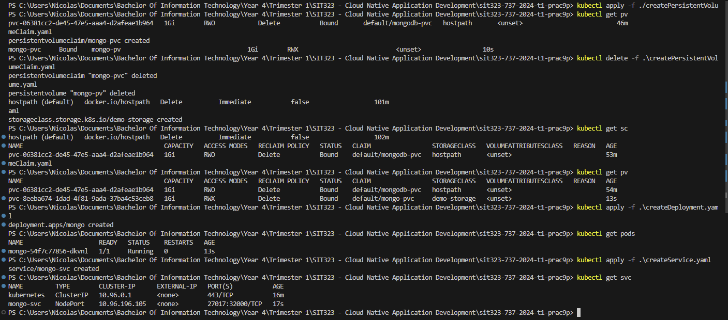

Workshop 9:

